3GPP TSG RAN WG1 #125 R1-2604754
Dalian, May 18th – 22nd, 2026

Title : RS design and Tx/Rx/measurement reporting procedures for ISAC
Source : NTT DOCOMO, INC., NTT, Inc.
Agenda item : 10.8.2
Document for: Discussion

Introduction
The 3GPP RAN plenary RAN#108 has approved a new SID, “Study on 6G Radio” [1]. Sensing in 6GR is included in this SID. The detailed focus of the study is as follows:
- Sensing – Studies to be based on use cases and associated requirements, as defined in [TR38.914]
- PHY functions and procedures for sensing technology (e.g., waveform. reference signals, measurement feedback, etc…) [RAN1, RAN4]
- Evaluate sensing performance and if necessary, extend channel modelling, for the selected use cases [RAN1]
- Aspects of integration with communication services [RAN1]
- higher layer procedures and protocol aspects [RAN2]
- RAN4 aspects of sensing including RF, coexistence, and testability in coordination with other WGs [RAN4]
Note: RAN1 identify detailed requirements, if triggered by TSG RAN
This contribution discusses aspects related to integration with communication services. More specifically, the detailed items include RS design, TX/RX procedures, operation, measurement reporting, and interference mitigation.

Discussion

High-level direction
Integrating sensing capabilities into the 6G RAN is expected to (i) provide new value and revenue opportunities for cellular networks beyond conventional connectivity services and (ii) contribute to further optimization of mobile network performance through enhanced environment awareness.
Regarding new value/revenue, ISAC-enabled 6GR can support novel services such as search-and-rescue missions in large disaster areas by leveraging network-deployed sensing to detect, localize, and track relevant objects. In addition, sensing can enable services based on statistical information of objects (e.g., vehicles), such as road traffic analytics and situational awareness, which can be monetized via APIs or enterprise solutions.
Regarding network performance optimization, sensing-derived information can be used for dynamic optimization of network parameters (e.g., beam/coverage configuration, resource allocation, and mobility settings) to better match instantaneous traffic and propagation conditions. Furthermore, long-term sensing observations can assist in planning tasks such as base-station placement optimization by identifying spatial/temporal distributions of users and objects.
Given the uncertainty around whether ISAC capabilities will be widely deployed in commercial 6G networks, especially in the early phase, introducing ISAC in a sustainable manner—with minimum additional overhead, cost, and operational complexity—is essential. From an operator’s perspective, ISAC designs that have a significant impact on communication performance, or require substantial additional CAPEX or OPEX, represent a high deployment risk under such uncertainty and are therefore difficult to justify. As a result, ISAC architectures that rely on major changes to existing network infrastructure tend to be deprioritized or excluded at the deployment stage. This leads to a chicken-and-egg situation, in which ISAC is not practically deployed due to limited confidence in its near-term value, while such confidence cannot be established precisely because large-scale deployment does not materialize. To break this cycle, ISAC should be designed to minimize impact on existing networks and enable incremental, low-risk adoption by mobile operators.
Integrating sensing into cellular NW may introduce non-negligible overhead and may degrade communication performance and efficiency if not carefully designed. Specifically, sensing RS TX/RX, measurement report, and control signalling may consume time-frequency-spatial resources that would otherwise be used for user data and control channels, resulting in resource overhead. Furthermore, depending on multiplexing and coordination, sensing transmissions may create additional interference to communication links, leading to communication-performance degradation. Finally, sensing operations may increase power consumption both at the network side (e.g., BS transmission and processing) and at the UE side (e.g., additional reception/processing and reporting), which should be considered from an energy-efficiency perspective.
Then, we propose the following:
Proposal 1: In 6GR, ISAC designs consider at least the following aspects
- Sensing performance
- Impact on communication
  - Resource overhead
  - Communication-performance degradation
  - power saving (NW and UE)
The acceptable sensing overhead depends on the intended sensing service. Continuous monitoring services, such as UAV detection and tracking, require sensing support to be continuously available, which may rely on communication resources or a very small amount of always-on sensing-dedicated resources. In such cases, the target overhead of dedicated sensing resources should be kept below 1%. As a reference point, the overhead of always-on signals such as SSB is typically below 1%, indicating a realistic upper bound for continuous sensing support. In contrast, opportunistic sensing services, such as digital twin generation or updates, do not require continuous availability and can exploit unused communication resources during low-traffic periods.
In RAN1#124 bis the following was agreed

Agreement:
- On RS for ISAC, study at least the following aspects, considering sensing performance, resource overhead and impact to communication
  - RS for communication is reused for sensing
  - Enhanced RS for sensing, taking reuse of RS for communication as starting point
    - Note: Part of or all of the RS may be used for communication purpose, and it does not mean the final decision on whether the enhanced RS is used for communication purpose is to be made in this agenda.
  - Dedicated RS for sensing
From the perspective of minimising the resource overhead , the first and second approaches, which are based on reusing communication signal/resources, are therefore preferred to be studied with equal or higher priority than the third approach.
Proposal 2: Study “RS for communication is reused for sensing” and “Enhanced RS for sensing, taking reuse of RS for communication as starting point” in equal or higher priority than “Dedicated RS for sensing”
- i.e., RAN1 should not prioritize dedicated RS for sensing

RS design

Metrics for ISAC RS
In RAN1#124bis, following agreement on the metrics for RE pattern study were made. However, which sensing and communication performance would be affected by RE pattern has not been discussed yet. In this subsection, we analyse all the candidate performance metrics and summarize the metrics related to the RE pattern.
Agreement:
- Study RE patterns of RS for sensing, considering sensing performance, resource overhead and impact to communication
- Note: enhancements on RS sequence if any will be discussed in agenda 10.8.3

RE pattern design metric for sensing
In OFDM systems, the effects of time delay caused by target distance and Doppler shift caused by target velocity on the received signals could be decoupled. Some theoretical relationships between sensing resource and performance are listed in Figure 1 .
- Resolution of range and velocity estimation are determined by the total occupied bandwidth and the coherent processing interval (CPI) of sensing signals, respectively, which are independent of the RE pattern.
- Accuracy of range and velocity estimation are determined by the resolution and received SNR.
  - Resolution: Determined by the allocated resources in time and frequency domain
  - SNR: Related to many factors, e.g., RE density (instead of RE pattern) , power boosting or not for the RS, BS or UE as sensing transmitter (with different maximum transmit power), peak-to-average power ratio (PAPR) of RS, beamforming gain, interference, etc.
    - RE density could be reflected by RS overhead.
    - PAPR would also be related to the RE pattern design in frequency domain.
- Maximum unambiguous value of range and velocity are determined by the RE pattern in frequency and time domain, respectively. For regular RS pattern (or comb pattern) as shown in Figure 2, the effective SCS determined by comb size L in frequency domain and the pulse interval (or periodicity) M₁T_{s} in time domain will affect the maximum unambiguous distance and velocity, respectively.
From above analysis, we can find that during the study of RE pattern of RS for sensing, at least maximum unambiguous values of velocity/range and PAPR should be considered for sensing performance.
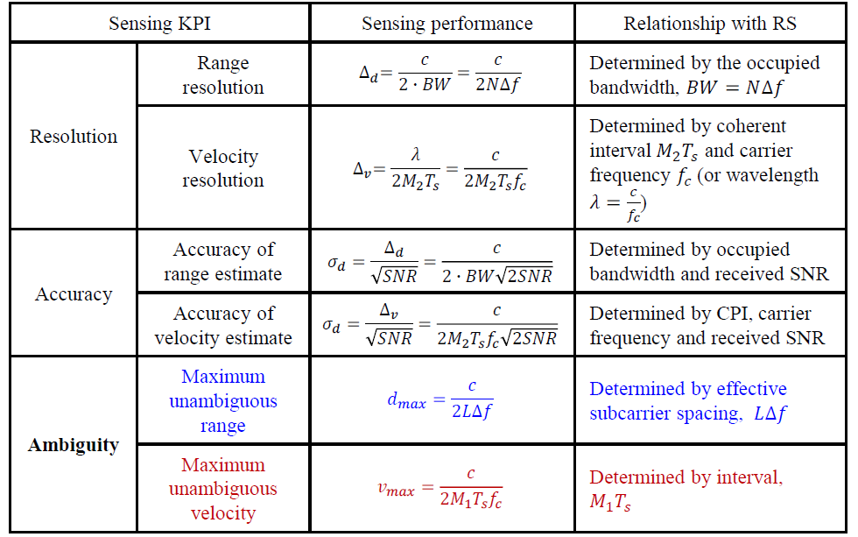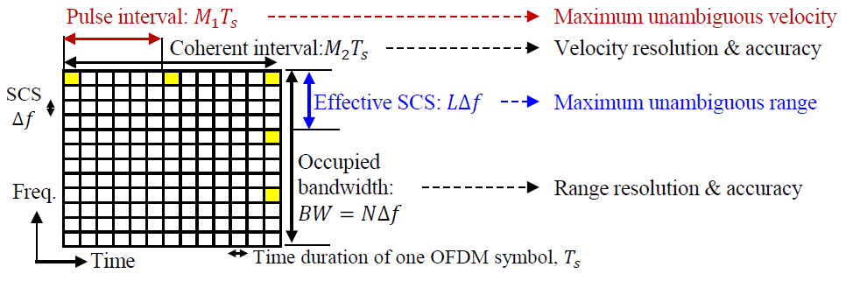
Figure 1 Relationship between RE pattern/resource and sensing KPI
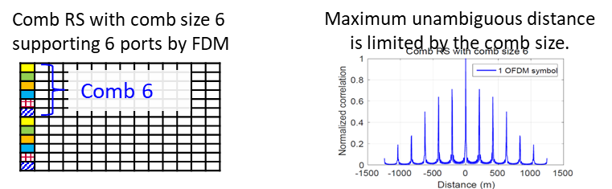 | 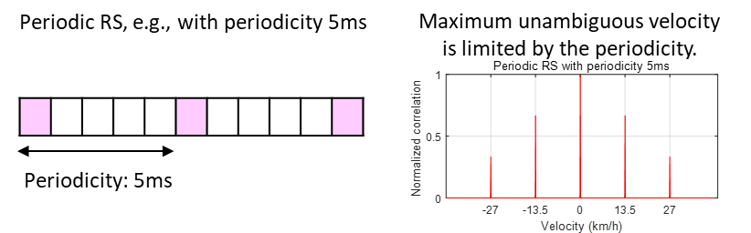
- Comb RS would cause distance ambiguity | - Periodic RS would cause velocity ambiguity
Figure 2 Illustration of distance/Velocity ambiguity caused by uniform RE pattern
Impact to communication
In addition to sensing performance, impact to communication should also be considered. Depending on whether the resources are shared by sensing and communication or dedicated for sensing, the impact to communication would be different. When same resources and signals are shared by sensing and communication, no additional resource overhead would be consumed by sensing. The only impact to communication would be the potential communication performance degradation caused by enhanced communication RS design for sensing. For example, if non-uniform RE pattern is used for TRS enhancement, the tracking and estimation performance on time/frequency errors may be degraded. However, when resources and/or signals are dedicated allocated for sensing, the RS may not be used for communication simultaneously. In this case, resource overhead and interference between sensing and communication would be the research focus.
From above analysis, we can find that at least resource overhead and communication performance degradation should be considered as the impact to communication during the RE pattern design. The interference between sensing and communication is expected to be handled by other mechanisms as discussed in Section 2.6.
Table 1 Analysis on the sensing performance and impact to communication
Resource | RS design | RE pattern design metric for sensing | Impact to communication
Same resource shared by sensing and communication | No enhancement from 6GR communication RS | - | -
 | Enhanced 6GR communication RS for sensing | - Maximum unambiguous values of velocity/range  - PAPR | - Communication performance degradation (e.g., degradation in tracking capability due to a non-uniform RE pattern)
Sensing dedicated resource | 6GR communication RS (w/ or w/o enhancement for sensing) | - Maximum unambiguous values of velocity/range  - PAPR | - Resource overhead  - Interference b/w sensing and communication
 | Sensing dedicated RS | - Maximum unambiguous values of velocity/range  - PAPR | - Resource overhead  - Interference b/w sensing and communication

Table 1 summarizes the relationship between sensing RS/resource, sensing performance and impact to communication. Based on which, following observation could be obtained.
Proposal 3: The design of RE patterns of RS for sensing should at least consider following metrics
- maximum unambiguous range/velocity
- PAPR
- resource overhead
- communication-performance degradation, etc.

RE pattern enhancement
When sensing requirements could not be satisfied by communication RS or be satisfied with large efforts, enhanced communication RS or dedicated RS could be considered for sensing. Nevertheless, the high-level direction should be satisfied, i.e., the impact to communication should be as small as possible while improving sensing performance.
We consider RS RE pattern enhancements that take sensing performance into account while satisfying the constraints of impact to communication performance.

Enhanced RS for sensing, taking reuse of RS for communication as starting point
Existing SRS for communication is not optimized as an observation signal for sensing. When communication SRS is reused for sensing, several limitations may arise. If SRS is concentrated in one or a small number of OFDM symbols, the time-domain observation points are limited, making it difficult to obtain doppler- or velocity-related information. In addition, since NR SRS phase continuity is guaranteed only within the same slot, the CPI may be short, which can limit velocity resolution and sensing accuracy.

To address this, one possible direction is to distribute SRS more sparsely in the time domain. For example, non-contiguous SRS symbol allocation can extend the observation time span while maintaining the same RE overhead as shown in figure 3, thereby improving doppler observability and partially mitigating the CPI limitation without increasing SRS resource overhead.
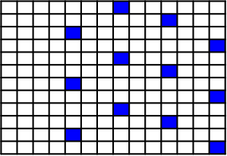
Figure 3 Illustration of non-contiguous time-domain allocation.

Another possible direction is to use a lower-density SRS configuration in the frequency domain as shown in figure 4. In the figure, the comb size is 2, and each colour corresponds to a different user. Instead of placing high-density SRS in a single symbol, the frequency-domain density can be reduced, and the corresponding REs can be distributed over multiple OFDM symbols. This increases the number of time-domain observation points while maintaining the same number of REs, and can improve velocity-related sensing capability

Figure 4 Illustration of low-density SRS symbol
However, these approaches involve trade-offs. Non-contiguous time-domain allocation may affect PUSCH/PUCCH scheduling, UL resource allocation, UE transmit power control, etc. Lower-density SRS can improve doppler/velocity observability, but may reduce frequency-domain observation density, leading to increased range ambiguity and degraded channel estimation accuracy. Therefore, SRS enhancements for sensing should be evaluated as a range–doppler–communication trade-off, considering impacts on range ambiguity, UL scheduling, MIMO operation, and the original communication performance of SRS.
Proposal 4: Study SRS enhancement for ISAC. Following directions are considered;
- Non-contiguous symbol allocation
- Low-density SRS symbol.

Dedicated RS for sensing – Non-uniform pattern for ISAC RS
As discussed in Section 2.2.1, the RE pattern determines the maximum unambiguous range/velocity. To improve this metric without increasing resource overhead, non-uniform RE pattern is proposed in the literature. One design method of non-uniform RE pattern is based on Compressed Sensing (CS) theory. Its core principle is to adopt random/pseudo-random non-uniform RE distribution in frequency-domain to construct a measurement matrix, and convert the distance ambiguity problem into a sparse signal reconstruction problem by leveraging the sparsity of targets in the range domain. However, this method faces several issues: first, advanced estimation algorithms (e.g., Orthogonal Matching Pursuit) is required with much higher complexity than FFT; second, non-uniform RE pattern in frequency-domain usually increases the PAPR for DFT-s-OFDM; third, there is no general closed-form formula for the measurement matrix, reconstructed solution and optimal non-uniform RE pattern in frequency-domain.
Another design method of non-uniform RE pattern is inspired by the multiple pulse-repetition-frequency (MRF) method in radar systems. The principle is to design a RS pattern composed by multiple comb sizes. As shown in Figure 5, although side peaks appear for each comb size, there is only one overlapping peak because the comb sizes are co-prime, which eliminates the distance ambiguity. As shown in Figure 6(a), the co-prime feature could be realized by time-division-multiplexing based (TDM-ed) or FDM-ed or interleaved RS with co-prime comb sizes alternatively. Even though the range ambiguity could be eliminated by the three multiplexing methods, FDM-ed and interleaved co-prime design would cause the irregular RS pattern in one OFDM symbol. Therefore, similar issues with the non-uniform RE pattern based on CS theory could be observed. For example, the PAPR of FDM-ed pattern would be increased as shown in Figure 6(b). Even though the PAPR of interleaved pattern is low, its compatibility with the communication RS is low and may increase the complexity at UE side. Therefore, TDM-ed co-prime RS composed by multiple uniform comb RSs is more suitable for sensing RS pattern, due to better compatibility with communication RS and lower computation complexity.
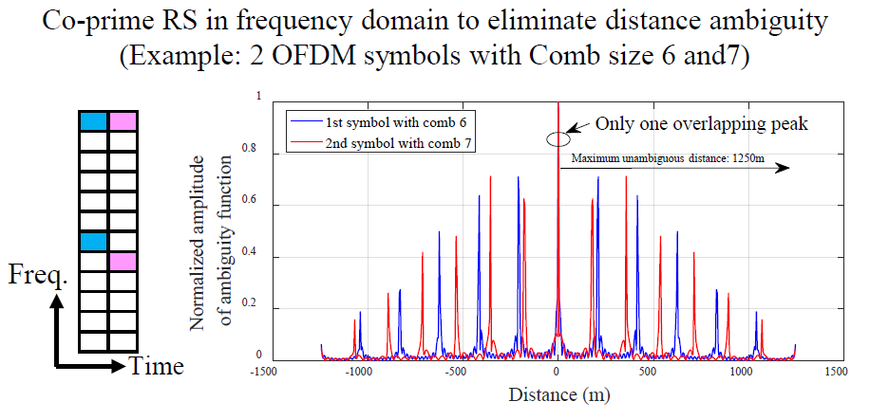
Figure 5 Illustration of co-prime RS to eliminate the distance ambiguity
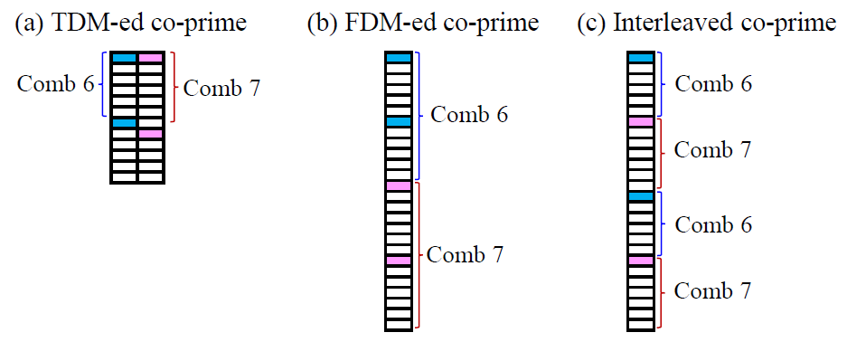
- 3 types of co-prime RE pattern | - PAPR comparison
Figure 6 Illustration of different co-prime RE patterns to eliminate the distance ambiguity
Based on similar principle, the co-prime RS pattern could be extended to multiple occasions. For OFDM system, the maximum unambiguous velocity is determined by RS periodicity. To eliminate the velocity ambiguity, at least two periodicities satisfying co-prime conditions should be considered. It should be noted that the unit of co-prime condition in time domain could be per OFDM symbol, or per slot, or per subframe, etc., which is related to the required maximum unambiguous velocity. Taking per slot as an example, two co-prime periodicities (e.g., 10 slots and 11 slots) could be considered for sensing RS transmission as shown in Figure 7, whose maximum unambiguous velocity is same with that with 1 slot periodicity.
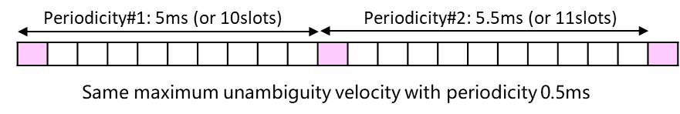
Figure 7 Illustration of sensing RS with two periodicities
The numerical performance on resource overhead and maximum unambiguous range/velocity are provided in Table 2. Results show that proposed co-prime features in frequency domain could obtain the largest maximum unambiguous range at the lowest resource overhead, and proposed co-prime periodicities in multiple occasions could obtain the highest maximum unambiguous velocity at the lowest resource overhead.
Table 2 Performance of resource overhead and maximum unambiguous range/velocity
RE pattern in frequency domain | Resource overhead per slot | Maximum unambiguous range
Block pattern with comb size 1 | 1/14≈7.14% | 1205 m
Uniform sparse RE pattern with comb size 3 (in one symbol) | 1/3/14≈2.38% | 402 m
Proposed RE pattern with two co-prime comb size [6,7] (in two symbols) | 1/3/14≈2.38% (Lowest) | 1205 m (Largest)

Periodicity in time domain | Resource overhead per periodicity | Maximum unambiguous velocity
0.5ms (e.g., 1slot) | 2.38%*1=2.38% | 135 km/h
5ms (i.e., 10slots) | 2.38%*1/10 = 0.24% | 13.5 km/h
Proposed RE pattern with two co-prime periodicities [5ms, 5.5ms] (i.e., 10slots and 11slots) | 2.38%*1/10 = 0.24% (Lowest) | 135 km/h (Highest)

It is noted that these RS designs could be applicable to “Enhanced RS for sensing, taking reuse of RS for communication as starting point” as well.
Observation 1: Non-uniform RS pattern in frequency domain and multiple occasions composed by multiple uniform RSs could achieve the benefits of both uniform and non-uniform RS pattern, e.g., good sensing ambiguity performance, low overhead, low PAPR, good compatibility with communication systems, etc.
Proposal 5 For dedicated RS for sensing, study non-uniform RS pattern in both time and frequency domains composed by multiple uniform RSs.

2.2.3 Evaluation for sensing RE pattern
Regarding how to evaluate the performance of sensing RE pattern, there are three alternatives.
- RE pattern characteristics analysis: Currently identified metrics for RE pattern study are PAPR and Ambiguity function (AF)-related metrics (e.g., maximum unambiguous range/velocity). RE pattern characteristics analysis at transmitter side is sufficient for these metrics’ evaluation.
- LLS: The necessity of LLS may depend on the RS types. For sensing performance, LLS is not preferred. For impact on communication, LLS could be considered.
  - Reused communication RS for sensing: Only sensing performance should be considered. For sensing performance evaluation, LLS channel model for sensing is not yet available and RE pattern characteristics analysis may be enough. However, if justified as necessary, LLS channel model for sensing should be firstly developed, followed by LLS on KPIs of range/velocity estimation accuracy (e.g., Root Mean Square Error, RMSE).
  - Enhanced communication RS for sensing: Both sensing performance and impact on communication performance should be considered. For sensing performance evaluation, share same views as “Reused communication RS for sensing”. For communication performance evaluation, LLS on communication metrics could be considered, e.g., BLER, channel estimation error, etc.
  - Dedicated sensing RS: Sensing performance should be prioritized, and same views could be shared as “Reused communication RS for sensing”.
- SLS: The necessity should be further studied, because the performance is not only determined by RE pattern but more related to the algorithm design. If identified as necessary, the KPIs defined for 6G ISAC could be considered for SLS, i.e., miss detection probability, false alarm probability, horizontal/vertical positioning accuracy and velocity accuracy.

Proposal 6: For evaluation of RE pattern design for sensing,
- RE pattern characteristics analysis focuses on metrics of PAPR and AF-related metrics (e.g., maximum unambiguous range/velocity) could be the first step for sensing RE pattern evaluation.
- FFS: The necessity of LLS and/or SLS evaluations for the sensing RE pattern study.

TX/RX procedure

Resource allocation/multiplexing with communication
RAN1 needs to study how sensing resources are allocated and how they are multiplexed with communication. Without such clarification, it is difficult to discuss other PHY aspects such as RS design, power control, etc., cannot be discussed based on consistent assumptions. Furthermore, it is necessary to consider not only sensing performance but also communication performance.
Resource allocation
From the resource-allocation perspective, it should be clarified which resource domains can be used for sensing-related transmissions, whether the corresponding resources are configured in a semi-static/preconfigured manner or dynamically allocated, and what granularity of resource configuration is needed. For communication performance considerations, dynamic allocation, as well as finer resource-allocation granularity, may provide benefits in terms of sensing performance by enabling more suitable sensing resource placement. On the other hand, such designs may increase control/signalling-related resource overhead and power consumption.
Multiplexing with communication
For the multiplexing with communication, it should be identified candidate multiplexing types, such as time, frequency, spatial and code-domain multiplexing. In addition, the design considerations associated with each multiplexing type should be clarified, since different multiplexing approaches may lead to different assumptions and requirements for other PHY aspects. For communication performance considerations, each multiplexing type may lead to different interference situations and different impacts on communication. Therefore, it is necessary to study how each multiplexing approach may affect communication performance.
Proposal 7: Study sensing resource allocation/multiplexing with communication in consideration of communication performance.
Regarding the study of resource allocation and multiplexing with communication, we believe that scenarios utilizing unused communication resources should be prioritized, since they are expected to have a lower impact on communication. In contrast, approaches such as measurement gaps or UL muting around sensing RS resources may introduce more explicit interruptions or constraints on communication and therefore should be considered with lower priority at this stage.
On the other hand, it is important to study how sensing RSs can be multiplexed with communication, including the multiplexing dimensions, rate matching, resource allocation granularity and collision handling.
Proposal 8: On resource multiplexing between sensing and communication, study at least the following aspects.
- TDM, FDM, CDM, SDM or using data in communication channel for sensing
- DL rate matching around sensing RS resources
- Resource allocation granularity
- Collison handling between sensing and communication

Power control including relation to communication power
For sensing modes with sensing RS transmission at UE side, how to decide transmission power is an important discussion. Although power control mechanisms will be discussed/specified for the communication purpose, we believe that power control for the sensing purpose should be different from that.
From sensing performance perspective, since sensing relies on observing reflected signals from targets, its power requirements are generally different from those of communication. For example, it may be better to determine the transmit power based on other than pathloss measurement results.
In addition, communication performance perspective should be considered to design the sensing power control. The transmit power used for sensing may affect not only the target detection capability, but also the interference experienced by communication links. For example, when larger power is used for the sensing purpose by a UE, other UE’s performance could be degraded due to inter-user and inter-cell interference.
Another aspect on power control is how the transmission power for sensing should be determined for each integration approach, i.e., for communication/sensing common signals/resources and for sensing dedicated signals/resources. The applicable/desirable power-control principles and constraints may differ between these approaches. For transmissions/resources dedicated to sensing, on the other hand, a more sensing-oriented power setting may be possible, but its impact on communication should still be carefully considered.
Proposal 9: Study power control mechanism for ISAC in consideration of:
- Both sensing performance and impacts to communication
- Two ISAC approaches of communication/sensing common signals/resources and sensing dedicated signals/resources

2.3.4 Beam management including relation to communication beam
Sensing-specific aspects
Sensing beam management (BM) would be important to ensure sensing performance, especially in FR2. For BS-only-involved sensing modes, sensing BM at BS side is up to implementation. For UE-involved sensing modes, e.g. BS-to-UE bistatic sensing, sensing BM can be studied.
If narrow sensing beam is used, when there is no prior knowledge of the target direction, e.g. for object detection or initial target search in wide-range sensing scenarios, sensing beam sweeping is needed. Narrower sensing beam is beneficial for higher sensing accuracy by focusing beam energy on target direction. Moreover, narrower sensing beam can help to distinguish adjacent targets, resulting in higher angular resolution. However, the required number of sweeping beams would be larger, which leads to higher sensing BM overhead. Therefore, study of sensing beam sweeping needs to consider both sensing performance requirement and sensing BM overhead.
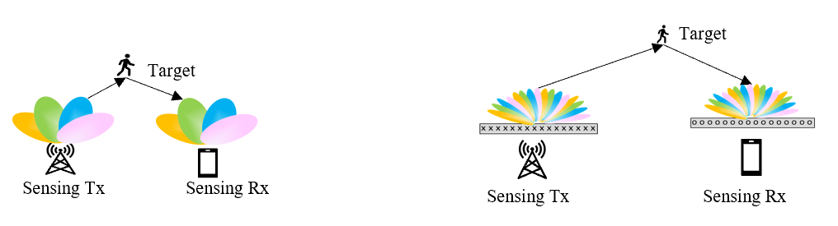
Figure 8 Example of sensing beam sweeping based on wide and narrow beams
If sensing task is object tracking or localization, a good sensing beam, which can be selected based on the initial sensing beam sweeping procedure, can be used without additional sweeping. It would be beneficial to reduce sensing BM overhead and enable lower latency sensing result.
Considering possible movement of target/UE, e.g. for high-mobility target tracking in UAV scenarios, the best sensing beam may need to be changed. Sensing beam tracking is needed. Similar to beam failure recovery in communication system, sensing beam failure recovery can be considered. When the target moves out of the range of the UE, e.g. no good sensing link can be identified for tracking a target by the UE. Sensing handover needs to be studied, e.g. NW switches the sensing task to another UE.
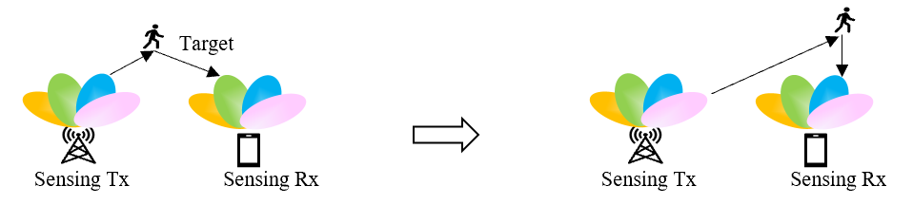
Figure 9 Example of sensing beam tracking
Interaction with communication beam management
Coordination between sensing and communication beam management also needs to be studied in ISAC system. For UE-involved sensing, the communication beam and sensing beam at UE side may be same or different. Independent or joint sensing and communication beam management can be considered, e.g. for different scenarios.
For example, if the communication beam and sensing beam are separate or independent, e.g. communication RS and sensing RS are non-overlapping in time domain, separate/independent sensing and communication beam management can be applied.
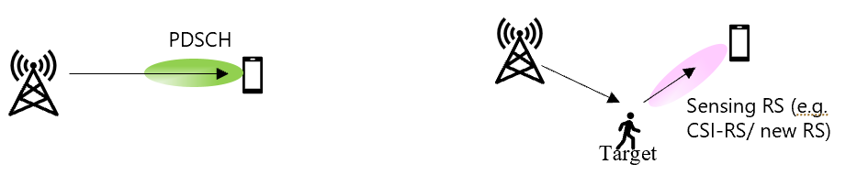
Figure 10 Example of separate/independent beams for sensing and communication
For another example, if certain communication RS/channel (e.g. DMRS of PDSCH/PDCCH) is reused for sensing, joint sensing and communication beam management may be needed, e.g. selection of the RS/channel beam needs to consider both communication performance and sensing performance.
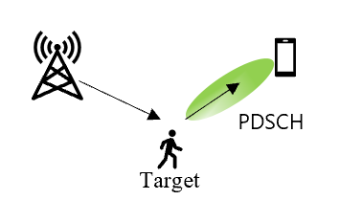
Figure 11 Example of same beam for sensing and communication
For another example, if SDMed communication and sensing resource multiplexing is applied, joint sensing and beam management to find a sensing and communication beam pair which can be received simultaneously and result in good sensing and communication performance.
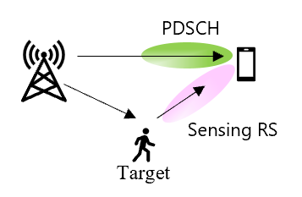
Figure 12 Example of SDMed beams for sensing and communication

Proposal 10: Study sensing beam management, including following aspects:
- Sensing beam sweeping, sensing beam selection, sensing beam tracking, sensing beam failure recovery, and handover
- Whether/how to consider interaction with communication beam management

2.3.5 Multi-layer sensing
This section will discuss multi-layer sensing, which utilizes RS-based channel measurements with multi-layers. ISAC using RSs can be achieved with either single-layer or multi-layer, as shown in Figure 13, since RSs can be transmitted either with single-layer or multi-layer.
ISAC is expected to support various sensing use cases, including NLOS environment. This scenario may make it more challenging to meet the required sensing accuracy and coverage. To address this issue, a solution could be to use more time-domain resources. Sensing accuracy can be improved by combining multiple sensing results, for example, through repeated single-layer sensing; however, it increases time-domain resource usage and thereby degrades communication efficiency. Furthermore, phase discontinuities across multiple sensing operations may also degrade sensing accuracy.
Another solution will be multi-layer sensing. We believe that multi-layer sensing can achieve accurate object detection and efficient resource block usage. By combining spatial information from multiple layers, the MIMO channel rank can be increased, enabling the use of radio waves with different spatial correlations and thereby enhancing sensing accuracy. Exploiting spatial information across layers can reduce the need for excessive additional time-domain resources while maintaining sensing accuracy, thereby improving resource block efficiency. These advantages can be achieved, particularly, when the target is located in a high-rank propagation environment with a large number of reflected paths.
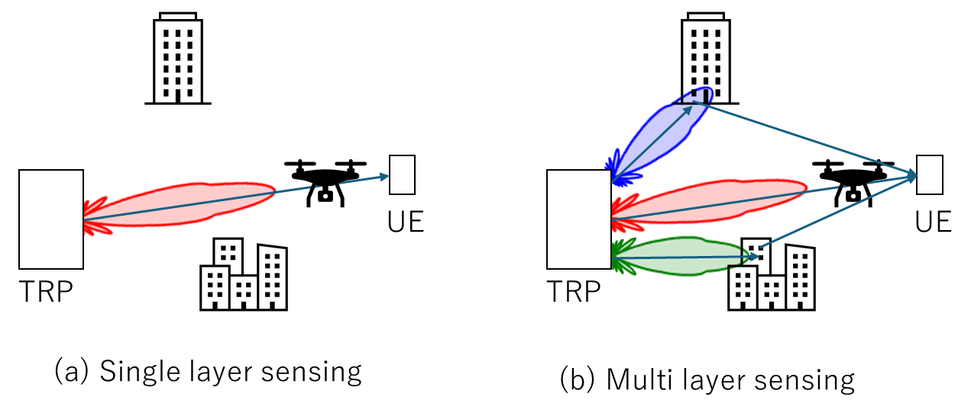
Figure 13 Single-layer and multi-layer sensing

For multi-layer sensing, RAN1 needs to have discussion on the following aspects, to collect multi-layer information and perform the associated calculations.
- RS design: which RS supports multi-layer sensing, the design details of the RS, etc.
- Resource allocation: how the RS for multi-layer sensing is scheduled, etc.
- Measurement/report: measured/reported quantity for multi-layer sensing, etc.
Proposal 11: Study sensing RS TX/RX with multiple ports.
- E.g., RS design, resource allocation, measurement/report details, etc.

Operation

Sensing trigger/activation/deactivation
Without clarifying the concepts of sensing RS Tx/Rx trigger, activation, and deactivation, it is difficult to establish consistent assumptions on sensing operation and timing, as well as to clarify the relation between sensing and other PHY aspects. From a time-domain viewpoint, sensing operation may exhibit different behaviors.
One possible behavior is periodic sensing RS Tx/Rx, where sensing is continuously or regularly active over time according to a predefined pattern. Another possible behavior is semi-persistent sensing RS Tx/Rx, where sensing remains active for a certain duration once configured or triggered. A further possible behavior is aperiodic or event-driven sensing RS Tx/Rx, where sensing is activated only when specific conditions or events occur.
Clarifying these different time-domain behaviors is important, since they may lead to different assumptions on sensing operation, timing relation with communication, and the design of related PHY procedures.
Proposal 12: Study the sensing RS TX/RX trigger/activation/deactivation

Sensing Tx/Rx node selection
In ISAC, it is necessary to determine which node is used as a sensing Tx node or a sensing Rx node in order to perform sensing. Such sensing Tx/Rx node selection is an integral part of the overall sensing procedure. Whether a given UE can actually operate as a sensing Tx/Rx node depends not only on higher-layer considerations but also on PHY-layer feasibility. Therefore, from a RAN1 perspective, it is necessary to evaluate whether a UE can perform sensing from the PHY-layer perspective.
From the RAN1 perspective, the main issue is to assess under what conditions a UE can operate as a sensing Tx/Rx node. As key targets of this feasibility assessment, UE states and UE availability can be considered. A point that deserves attention is that, while “Sensing Tx/Rx node selection” may seem to be a discussion topic from NW perspective, we should discuss from a UE perspective with specification impact explicitly considered, that is, whether each UE can/should perform sensing or not.
One important aspect is the impact of UE states, particularly RRC states, on the feasibility of operating as a sensing node. For example, depending on the UE’s RRC state, the feasibility of sensing RS transmission, reception, measurement, and reporting may differ. Therefore, for each UE state, RAN1 can organize the discussion from a PHY-layer perspective on whether the UE can operate as a sensing Tx node, whether it can operate as a sensing Rx node, whether the synchronization, configuration, and resources required for sensing RS transmission, reception, and measurement are available, whether/how the UE should perform state transition, and whether additional PHY-layer mechanisms are required to enable sensing operation in that state. Such discussion can help clarify which UE states may allow the UE to be treated as a sensing node and which UE states may impose significant constraints.
Another important aspect is UE availability. UE availability can be understood as whether a UE is usable as a sensing Tx/Rx node under a given timing, condition, and configuration. This concept should be clearly distinguished from UE capability. UE capability indicates whether the UE supports sensing Tx/Rx functionality in general, whereas UE availability indicates whether the UE can practically be used as a sensing Tx/Rx node under its current state and conditions. For example, even if a UE supports sensing functionality, it may not be available as a sensing node due to its current communication state, power state, availability of measurement opportunities, reporting feasibility, or potential resource collisions. Therefore, it is important for RAN1 to identify and clarify the PHY-layer conditions required to determine UE availability.
Proposal 13: RAN1 to study Sensing Tx/Rx node selection from UE perspective, which can be categorized into the two parts below:
- Which RRC state UE can perform sensing in.
- Whether UE supporting sensing is willing to perform sensing at a given timing.

2.4.3 UE positioning
Sensing calculator will use the location information at both RS TX and RS RX, to derive the corresponding sensing geometry. That is, for UE-related sensing, i.e., UE-BS/BS-UE bistatic, UE-UE monostatic sensing, the UE’s location information is an essential information. Without reliable UE location information, it may be difficult to associate sensing results with the correct spatial context and to properly utilize UE-related sensing outcomes. Therefore, how to obtain UE’s location information with high accuracy is a key discussion to satisfy the sensing performance requirements.
Possible ways to obtain UE position include the following:
- GNSS, where UE location is obtained based on satellite positioning information.
- RAT-dependent positioning, where UE location is obtained using positioning methods supported by the radio access technology.
The method used to obtain UE location may affect the availability, accuracy, and applicability of UE-related sensing. At the same time, other aspects should be considered, such as whether to rely on non-3GPP features (similar discussion to GNSS-based/GNSS-less in NTN), whether/how to support RAT-dependent positioning (no RAN1 AI for this topic in 6G discussion so far).
Proposal 14: Study how to obtain UE location for ISAC

2.4.4 Inter-band sensing
For sensing availability in wider area, utilizing lower frequency band is a potential option from the coverage performance perspective. Having said that, the bandwidth of each individual carrier may be insufficient from a sensing perspective, i.e., low sensing resolution.
On the other hand, relying only on higher-frequency bands may also be insufficient from a sensing perspective, since such bands, while offering larger bandwidth, may be more vulnerable to blockage and propagation limitations depending on the environment. Therefore, from a sensing perspective, it may be beneficial not only to aggregate multiple carriers/bands in order to increase the effective bandwidth, but also to jointly utilize bands with different propagation characteristics so that their sensing capabilities can complement each other under different deployment and channel conditions.
Accordingly, the possibility of inter-band sensing, including both bandwidth aggregation across multiple carriers/bands and joint utilization of bands with different propagation characteristics, should be studied for ISAC.
Proposal 15: Study inter-band sensing in ISAC.

2.4.5 Energy efficiency
For 6GR, energy efficiency is one of the most important features. In the communication AIs, all functionalities will be designed taking energy efficiency perspective into account. If ISAC is not designed in accordance with energy-efficiency principles, it will not be possible to achieve the energy-efficiency targets envisioned for 6GR. A fundamental challenge arises from the different design directions of 6G energy efficiency and sensing integration. While energy-efficient design generally aims to reduce always-on signalling, unnecessary transmission/reception, and continuous resource usage, sensing tends to exploit available system resources as much as possible in order to enhance sensing performance, for example through more frequent transmission/reception, denser resource usage, or additional sensing-related processing. As a result, ISAC design needs to carefully balance sensing capability and energy efficiency, taking into account the impact on both NW-side and UE-side power consumption.
Therefore, energy efficiency should be considered as an important design aspect of 6GR ISAC, and the associated trade-offs between sensing performance and energy consumption should be studied.
Proposal 16: Study 6GR ISAC considering energy efficiency at both NW side and UE side.

Measurement/report

Measurement quantity
In 5G-A ISAC study on UAV detection and tracking of gNB-based monostatic sensing, 4 measurement levels were defined by RAN1 based on the trade-off between payload size and performance.
- Level A: Raw data per TRP
- Level B: Delay-doppler-angle profile per TRP
- Level C: Path/point level measurement per TRP
- Level D: Object/target level measurement per gNB
In RAN1#124bis, it was agreed to take the measurement levels studied in NR ISAC as starting point for the measurement definitions/levels for TRP-side measurement. In the latest RAN3 meeting, it was agreed not to support measurement level A in NR ISAC, which should be taken into consideration in 6G ISAC study in RAN1.
Agreement of RAN1#124bis:
- On measurement for ISAC, study at least the following aspects.
  - Measurement definitions/levels for TRP-side measurement, taking the measurement Levels studied in NR ISAC as starting point
  - Measurement definitions/levels for UE-side measurement
  - Impacts of non-ideal factors on measurement
  - Other aspects are not precluded
  - Note: this discussion may or may not mean there is specification impact
Agreement of RAN3#131bis:
- Measurement level A is not supported
- Further discuss specification impacts of measurement levels B, C, D and consider further down-selection

In addition, based on the payload size calculation equation and assumption in TR38.765 for NR ISAC, level B consumes 113Mbit to 16.5Gbit, while level C/D consume several to tens of Kbit as shown in Figure 14.
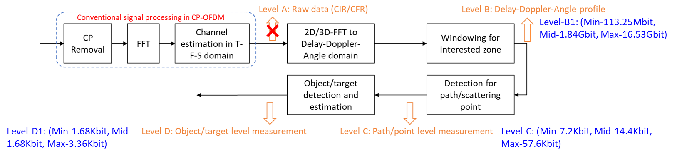
Figure 14 Measurement levels defined in 5G-A ISAC
By jointly considering the payload size and latest progress of RAN3, we could obtain following observation.
Observation 2:
- For TRP-side measurement, level B/C/D could be studied as the starting point.
- For UE-side measurement, level B/C/D could be further down-selected and enhanced for lower payload size or better sensing results.

Assistance information
To help further processing at Sensing Function, assistance information for each measurement level is proposed for 5G-A ISAC. The details in [TR38.765] are listed below for better understanding.

5.3 Assistance information
For Level A/B, at least the following examples of assistance information are identified as needed to assist the further processing at Sensing Function. Additional assistance information is not precluded. The assistance information may or may not be provided by RAN.
- Level A
- Location of TRP
- Step size in delay domain if samples in delay domain is reported
- Time information related to OFDM symbols used for measurement
- Antenna configuration and/or beam information
- Level B
- Location of TRP
- LCS to GCS transformation information
- Information related to sampling of delay, Doppler and/or angle profile
For Level C, at least the following examples of assistance information are identified as needed to assist the further processing at Sensing Function. The assistance information may or may not be provided by RAN.
- Location of TRP if at least delay/range, Doppler/radial velocity or angle is reported
- If a measurement is reported in LCS, LCS to GCS transformation information
For Level D, if radial velocity is not reported, no assistance information is identified from physical layer perspective.

For 6G ISAC, when BS performs the sensing measurement, e.g., TRP monostatic, TRP-TRP or UE-TRP bistatic sensing, the assistance information in 5G-A ISAC could be considered as the baseline and starting point. When UE performs the sensing measurement, e.g., for UE monostatic, TRP-UE or UE-UE bistatic sensing, the assistance information may be provided by UE to RAN or to Sensing Function. The assistance information in 5G-A ISAC should be updated, e.g., at least the location of UE should be reported instead of location of TRP, which is discussed in 2.4.3. Furthermore, if the cooperation between multiple TRPs or multiple UEs are supported for sensing result fusion, the assistance information among multiple sensing transceivers or between multiple sensing transceivers and Sensing Function/RAN should also be studied.
Proposal 17:
- Assistance information defined in 5G-A ISAC for gNB-based monostatic sensing could be studied as the baseline and starting point of 6G ISAC.
- For each sensing mode and scenario, study the necessity and potential enhancement for assistance information.

Measurement report mechanism
In RAN1#124bis, following agreements were made on the measurement reporting mechanisms, i.e., sent from UE to aNB or SF in option 1A/1B and sent from aNB to UE or SF in option 2A/2B. In RAN3#131bis, Nx interface is defined between the gNB and the SF, e.g., direct or via the AMF.
Agreement:
- On measurement report for ISAC, study at least the following aspects and applicable scenarios (e.g., sensing modes, targets, etc.) from RAN1 perspective.
  - Measurement reporting mechanism from UE
    - Option 1A: The UE measurements and/or assistance information if needed from UE can be directly sent to aNB
    - Option 1B: The UE measurements and/or assistance information if needed from UE can be sent to SF
  - Measurement reporting mechanism from aNB
    - Option 2A: The aNB measurements and/or assistance information if needed from aNB can be directly sent to UE
    - Option 2B: The aNB measurements and/or assistance information if needed from aNB can be sent to SF
  - The study may require cross-WG coordination.
  - Note: combination of multiple options is not precluded.
  - Note: measurements in each option may be different

For 6G ISAC, level B/C/D could be considered as the starting point of measurement definitions/levels of TRP-side and UE-side measurement and Nx interface could be considered as the starting point for the measurement reporting mechanism from aNB to SF in option 2B. For other options, due to following reasons, the measurement reporting mechanism may be further studied.
- Sensing modes: In 5G-A ISAC, gNB-based monostatic sensing is supported, whose measurements are reported from RAN to sensing function. This indicates that the allowable maximum payload size may be large. For 6G ISAC, all the six sensing modes should be studied with or without prioritization. If the UE measurements need to be reported via air interface in 6G, e.g., for TRP-UE bistatic sensing, the measurements may be enhanced for lower payload size or better sensing results. Therefore, the measurements should be studied for each sensing mode.
- Sensing use cases: In 5G-A ISAC, target detection and tracking is considered as the usage scenario, with UAV as the target object. Towards 6G ISAC, two types of use cases should be studied, including UC#1 of object detection and/or tracking for target/object types of UAV (outdoor), human (indoor and outdoor), vehicle (outdoor), AGV (indoor), UC#2 of communication assistance. Even though the technical performance requirement (TPR) of sensing is same for UC#1 and UC#2 in RAN as defined in [TR38.914], the latency requirement may be different, which may affect the consumer of measurement report and hence the visibility to aNB for UE measurements and/or assistance information in option 1A/1B. Based on whether the UE measurements and/or assistance information are transparent to aNB, the measurement reporting mechanism of different use cases could be further studied. For examples, for UC#1, the UE measurements and/or assistance information could need to be transparent to aNB. For UC#2, either transparent or non-transparent to aNB could be considered, depending on the specific use case of communication assistance.
Based on above analysis, we could classify the measurement reporting mechanisms, signaling, and measurement reports of different sensing modes into Table 3.
- Option 1A and option 2B could be combined if the UE measurements and/or assistance information are non-transparent to aNB.
- The necessity of option 2A is questionable and unclear, which should be further studied.
- For the reporting of measurements and/or assistance information from handheld UEs to aNB/SF or from aNB to UE (if supported), the reporting would be on L1, L2 or higher layer. The payload size of measurement reports should be carefully studied. For example, we could prioritize level C and level D and support level B only if the payload size is greatly reduced. For other special UE types, e.g., CPE, the acceptable payload size may be larger than handheld UE and the measurement reports could be further studied.
Table 3 Reporting mechanism, signaling and measurement report for different sensing modes
Sensing modes | Reporting mechanism and signaling | Measurement report
UE-side measurement reporting: UE monostatic/aNB-UE bistatic/UE-UE bistatic | Option 1B: UE-SF (Transparent to aNB)  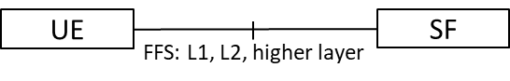 | UE to aNB/SF: Prioritize Level C/D. Support Level B only if the payload size is greatly reduced.  FFS: Special UE type, e.g., CPE
Option 1A: UE-aNB (Non-transparent to aNB)
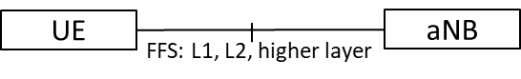
 | Option 1A+2B: UE-aNB-SF  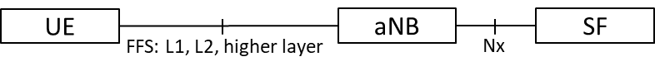 | aNB to SF: Level B/C/D could be further studied.
TRP-side measurement: aNB monostatic/aNB-aNB bistatic/UE-aNB bistatic | Option 2B: aNB-SF  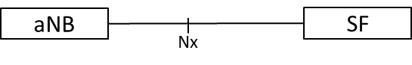
 | Option 2A: aNB-UE  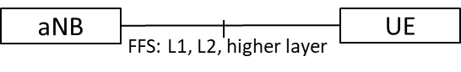 | aNB to UE (If supported, the necessity should be justified): Prioritize Level C/D. Support Level B only if the payload size is greatly reduced.

Proposal 18:
- For the reporting of aNB measurements and/or assistance information from aNB to SF, logical architecture for NR ISAC could be considered as the starting point.
- For the reporting of aNB measurements and/or assistance information from aNB to UE,
  - The necessity should be further justified.
  - if supported after study, prioritize level C and level D, and support level B only if the payload size could be reduced
- For the reporting of UE measurement and/or assistance information from UE to aNB or SF, prioritize level C and level D and support level B only if the payload size could be reduced.
  - Note: Handheld UE is assumed. FFS: measurement levels for special UE types, e.g., CPE.

Interference mitigation
In ISAC system, there are some new interference types compared to communication only system, including:
- Self-interference: Transmission of sensing signal interferes sensing signal measurement/RX at the same node.
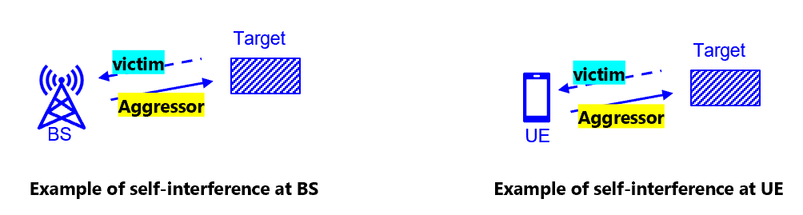
Figure 15 Example of self-interference
- Interference between sensing signals:
  - BS-to-UE interference between sensing signals: Sensing channel/signal from BS interferes sensing signal RX at UE.
  - UE-to-BS interference between sensing signals: Sensing channel/signal from UE interferes sensing signal RX at BS.
  - BS-to-BS interference between sensing signals: Sensing channel/signal from a BS interferes sensing signal RX at another BS.
  - UE-to-UE interference between sensing signals: Sensing channel/signal from a UE interferes sensing signal RX at another UE.
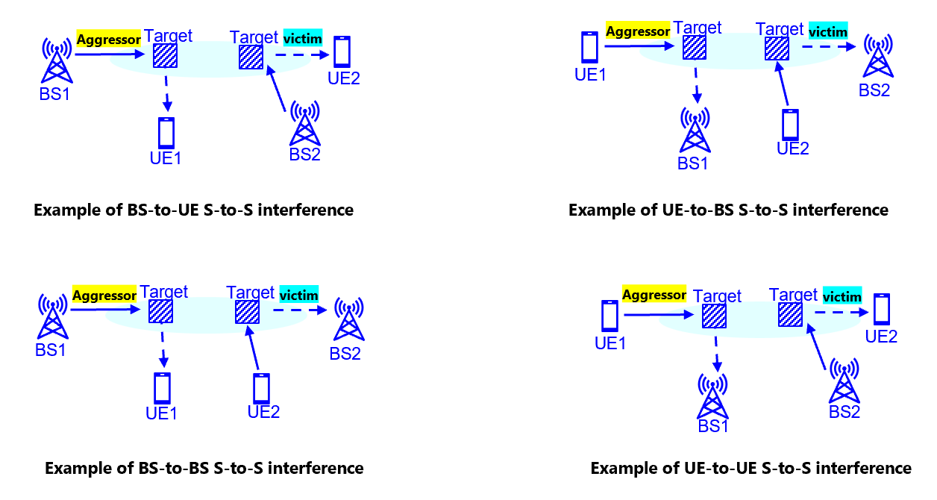
Figure 16 Example of interference between sensing signals
- Interference between sensing and communication
  - BS-to-UE interference between communication and sensing signals: Communication/Sensing channel/signal from BS interferes sensing/communication channel/signal RX at UE.
  - UE-to-BS interference between communication and sensing signals: Communication/Sensing channel/signal from UE interferes sensing/communication channel/signal RX at BS.
  - BS-to-BS interference between communication and sensing signals: Communication/Sensing channel/signal from a BS interferes sensing/communication channel/signal at another BS.
  - UE-to-UE interference between communication and sensing signals: Communication/Sensing channel/signal from a UE interferes sensing/communication channel/signal at another UE.
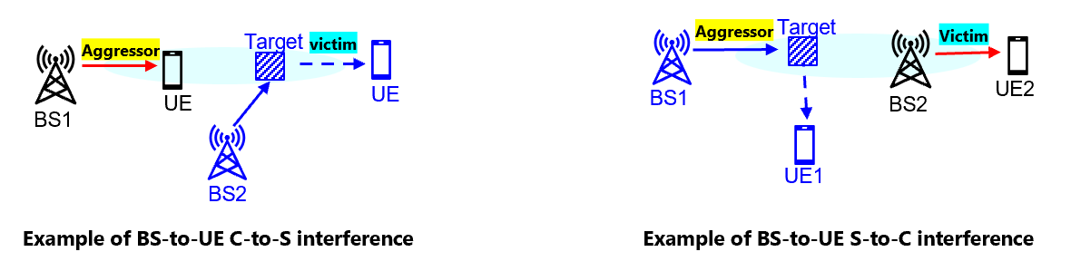
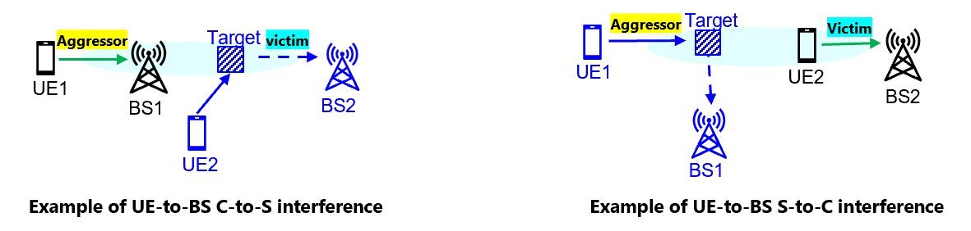
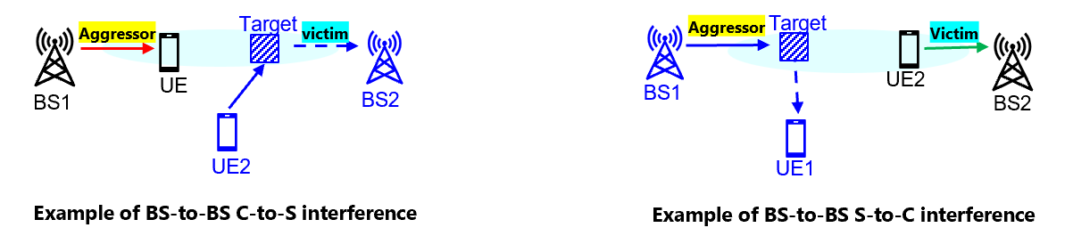
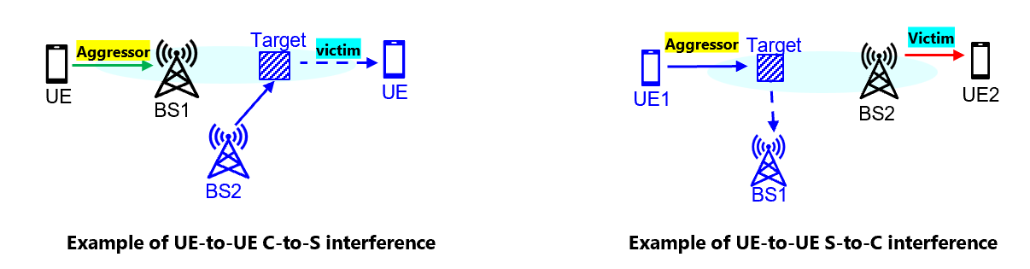
Figure 17 Example of interference between sensing and communication
For self-interference, it is present only in TRP/UE monostatic sensing modes. It can be handled by physical isolation of TX and RX (e.g. separate RF/antennas/hardware), advanced receiver algorithm, etc.
If communication and sensing signals are separated in time domain from system perspective, e.g. if dedicated sensing symbol/slot pattern configuration is introduced and aligned among neighbor cells, interference between communication and sensing signals doesn’t exist.
If DL/UL slot direction pattern are aligned among neighbor cells, BS-to-UE and UE-to-BS interference between sensing signals doesn’t exist.
For interference between sensing and communication, and interference between sensing signals, if communication channel/signal is reused for sensing, e.g. as discussed in section 2.2, the interference situation is same as interference in communication-only system. For example, BS-to-UE and UE-to-BS interference between sensing and communication, BS-to-UE and UE-to-BS interference between sensing signals, are similar to the BS-to-UE and UE-to-BS interference in communication-only system. Inter-cell interference (ICI) mitigation schemes in communication-only system can be reused. BS-to-BS and UE-to-UE interference between sensing and communication, BS-to-BS and UE-to-UE interference between sensing signals, are similar to BS-to-BS CLI, UE-to-UE CLI in communication-only system. CLI mitigation schemes in communication-only system can be reused.
If dedicated sensing RS is used, e.g. as discussed in section 2.2, the interference characteristics of interference between sensing and communication and interference between sensing signals may be different from the interferences in communication-only systems. Whether the interference can be handled by the interference mitigation schemes in communication-only system needs further study.
Proposal 19:
- Study potential interference types and characteristics (including presence/magnitude, etc.) in ISAC system.
- Study whether interference mitigation is needed and if needed, potential techniques for interference mitigation, considering sensing RS design.

Conclusion
In this contribution, the issues related to RS design and Tx/Rx/measurement/reporting procedures for ISAC were discussed. The following observations and proposals were made as conclusions.
Proposal 1: In 6GR, ISAC designs consider at least the following aspects
- Sensing performance
- Impact on communication
  - Resource overhead
  - Communication-performance degradation
  - power saving (NW and UE)
Proposal 2: Study “RS for communication is reused for sensing” and “Enhanced RS for sensing, taking reuse of RS for communication as starting point” in equal or higher priority than “Dedicated RS for sensing”
- i.e., RAN1 should not prioritize dedicated RS for sensing
Proposal 3: The design of RE patterns of RS for sensing should at least consider following metrics
- maximum unambiguous range/velocity
- PAPR
- resource overhead
- communication-performance degradation, etc.
Proposal 4: Study SRS enhancement for ISAC. Following directions are considered;
- Non-contiguous symbol allocation
- Low-density SRS symbol.
- Observation 1: Non-uniform RS pattern in frequency domain and multiple occasions composed by multiple uniform RSs could achieve the benefits of both uniform and non-uniform RS pattern, e.g., good sensing ambiguity performance, low overhead, low PAPR, good compatibility with communication systems, etc.
- Proposal 5 For dedicated RS for sensing, study non-uniform RS pattern in both time and frequency domains composed by multiple uniform RSs.
Proposal 6: For evaluation of RE pattern design for sensing,
- RE pattern characteristics analysis focuses on metrics of PAPR and AF-related metrics (e.g., maximum unambiguous range/velocity) could be the first step for sensing RE pattern evaluation.
- FFS: The necessity of LLS and/or SLS evaluations for the sensing RE pattern study.
Proposal 7: Study sensing resource allocation/multiplexing with communication in consideration of communication performance.
Proposal 8: On resource multiplexing between sensing and communication, study at least the following aspects.
- TDM, FDM, CDM, SDM or using data in communication channel for sensing
- DL rate matching around sensing RS resources
- Resource allocation granularity
- Collison handling between sensing and communication
Proposal 9: Study power control mechanism for ISAC in consideration of:
- Both sensing performance and impacts to communication
- Two ISAC approaches of communication/sensing common signals/resources and sensing dedicated signals/resources
Proposal 10: Study sensing beam management, including following aspects:
- Sensing beam sweeping, sensing beam selection, sensing beam tracking, sensing beam failure recovery, and handover
- Whether/how to consider interaction with communication beam management
Proposal 11: Study sensing RS TX/RX with multiple ports.
- E.g., RS design, resource allocation, measurement/report details, etc.
Proposal 12: Study the sensing RS TX/RX trigger/activation/deactivation
Proposal 13: RAN1 to study Sensing Tx/Rx node selection from UE perspective, which can be categorized into the two parts below:
- Which RRC state UE can perform sensing in.
- Whether UE supporting sensing is willing to perform sensing at a given timing.
Proposal 14: Study how to obtain UE location for ISAC
Proposal 15: Study inter-band sensing in ISAC.
Proposal 16: Study 6GR ISAC considering energy efficiency at both NW side and UE side.
Observation 2:
- For TRP-side measurement, level B/C/D could be studied as the starting point.
- For UE-side measurement, level B/C/D could be further down-selected and enhanced for lower payload size or better sensing results.
Proposal 17:
- Assistance information defined in 5G-A ISAC for gNB-based monostatic sensing could be studied as the baseline and starting point of 6G ISAC.
- For each sensing mode and scenario, study the necessity and potential enhancement for assistance information.
Proposal 18:
- For the reporting of aNB measurements and/or assistance information from aNB to SF, logical architecture for NR ISAC could be considered as the starting point.
- For the reporting of aNB measurements and/or assistance information from aNB to UE,
  - The necessity should be further justified.
  - if supported after study, prioritize level C and level D, and support level B only if the payload size could be reduced
- For the reporting of UE measurement and/or assistance information from UE to aNB or SF, prioritize level C and level D and support level B only if the payload size could be reduced.
  - Note: Handheld UE is assumed. FFS: measurement levels for special UE types, e.g., CPE.
Proposal 19:
- Study potential interference types and characteristics (including presence/magnitude, etc.) in ISAC system.
- Study whether interference mitigation is needed and if needed, potential techniques for interference mitigation, considering sensing RS design.

ANNEX: All agreements

RAN1 #124bis

Agreement:
- On RS for ISAC, study at least the following aspects, considering sensing performance, resource overhead and impact to communication
  - RS for communication is reused for sensing
  - Enhanced RS for sensing, taking reuse of RS for communication as starting point
    - Note: Part of or all of the RS may be used for communication purpose, and it does not mean the final decision on whether the enhanced RS is used for communication purpose is to be made in this agenda.
  - Dedicated RS for sensing

Agreement:
- Study RE patterns of RS for sensing, considering sensing performance, resource overhead and impact to communication
- Note: enhancements on RS sequence if any will be discussed in agenda 10.8.3

Agreement:
- On measurement for ISAC, study at least the following aspects.
  - Measurement definitions/levels for TRP-side measurement, taking the measurement Levels studied in NR ISAC as starting point
  - Measurement definitions/levels for UE-side measurement
  - Impacts of non-ideal factors on measurement
  - Other aspects are not precluded
  - Note: this discussion may or may not mean there is specification impact

Agreement:
- On measurement report for ISAC, study at least the following aspects and applicable scenarios (e.g., sensing modes, targets, etc.) from RAN1 perspective.
  - Measurement reporting mechanism from UE
    - Option 1A: The UE measurements and/or assistance information if needed from UE can be directly sent to aNB
    - Option 1B: The UE measurements and/or assistance information if needed from UE can be sent to SF
  - Measurement reporting mechanism from aNB
    - Option 2A: The aNB measurements and/or assistance information if needed from aNB can be directly sent to UE
    - Option 2B: The aNB measurements and/or assistance information if needed from aNB can be sent to SF
  - The study may require cross-WG coordination.
  - Note: combination of multiple options is not precluded.
  - Note: measurements in each option may be different

Agreement:
- On measurement report for ISAC, study impacts from at least the following aspects from RAN1 perspective
  - Measurement reporting mechanism
    - E.g., Periodic, semi-persistent, aperiodic, event-triggered report as starting point
    - Reporting signaling e.g., L1, L2, higher layer, etc.
  - Other aspects are not precluded
  - The study may require cross-WG coordination.

References
[1] RP-251881 New SID: Study on 6G Radio

